**Network Programming for Engineers (ECE 5650)**

**Project 1**

**Team Members Names: Anika Tasnim & Li Lin**

Q1. What is the IP address and TCP port number used by your client computer (source) to transfer the file to gaia.cs.umass.edu?

Answer:

Client IP: 192.168.0.12

Port: 57366

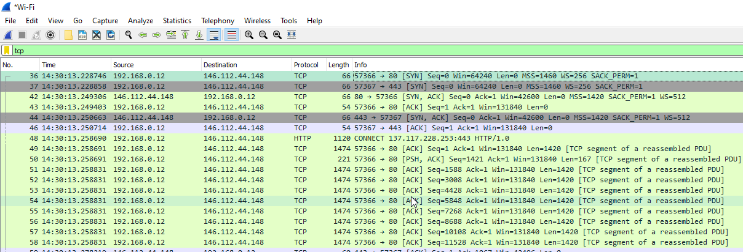

Q2. What is the IP address and TCP port number used by the client computer (source) that is transferring the file to gaia.cs.umass.edu?

Answer:

Client IP:192.168.1.102

Port: 1161

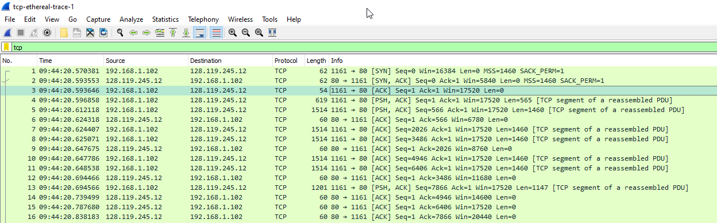

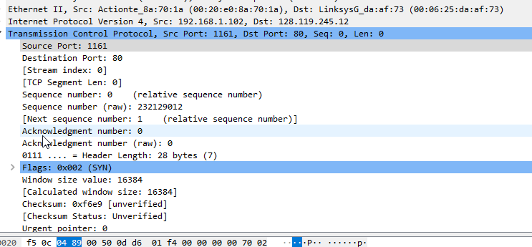

Q3. What is the IP address of gaia.cs.umass.edu? On what port number is it sending and receiving TCP segments for this connection?

Answer:

Server IP: 128.119.245.12

Port: 80



3. TCP Basics

For the *tcp-ethereal-trace-1* in http://nabil.eng.wayne.edu/ece5650/wireshark-traces.zip, answer the following questions for the TCP segments:

Q4. What is the sequence number of the TCP SYN segment that is used to initiate the TCP connection between the client computer and gaia.cs.umass.edu? What is it in the segment that identifies the segment as a SYN segment?

Answer:

Sequence number is 232129012.

The Flags filed, the bit1 is indicating if the segment is SYN segment.

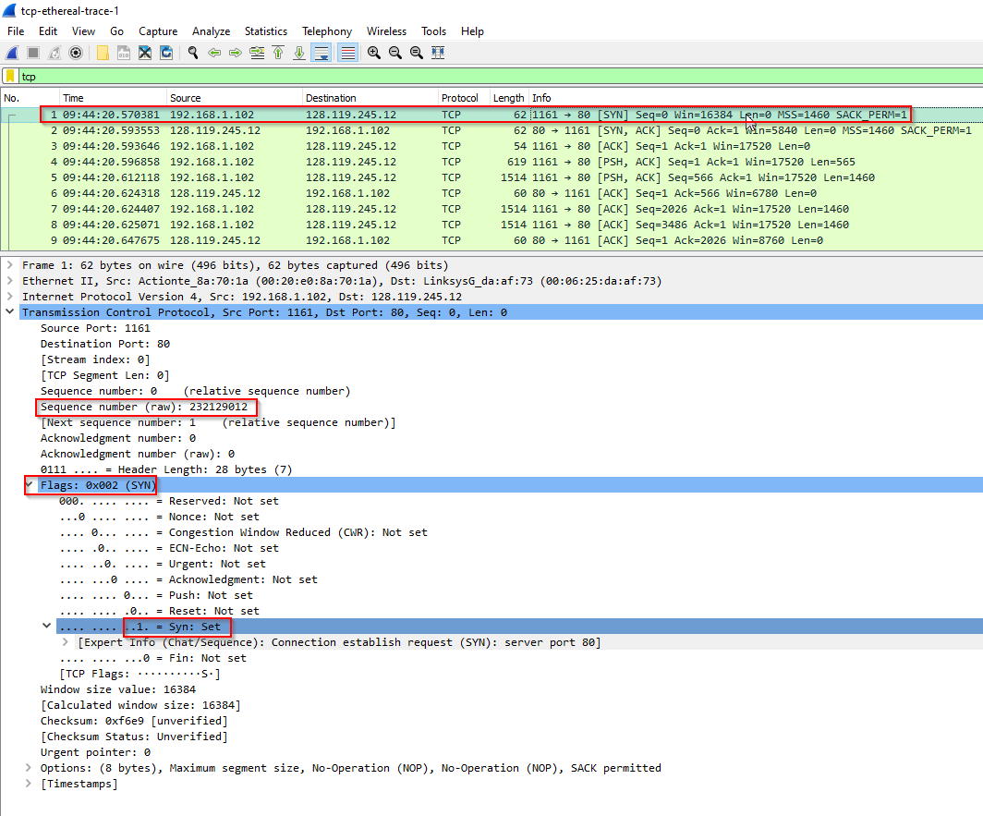

Q5. What is the sequence number of the SYNACK segment sent by gaia.cs.umass.edu to the client computer in reply to the SYN? What is the value of the Acknowledgement field in the SYNACK segment? How did gaia.cs.umass.edu determine that value? What is it in the segment that identifies the segment as a SYNACK segment?

Answer:

Sequence number: 883061785

ACK number: 232129013 which is the sequence number from client SYN segment plus 1.

In Flags filed, bit1(SYN) is indicating if this is SYNACK segment

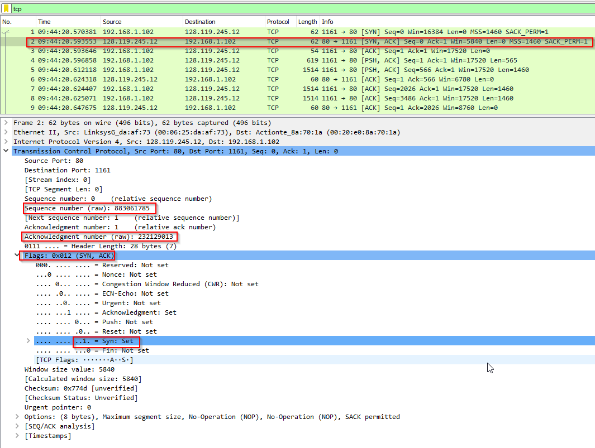

Q6. What is the sequence number of the TCP segment containing the HTTP POST command? Note that in order to find the POST command, you’ll need to dig into the packet content field at the bottom of the Wireshark window, looking for a segment with a “POST” within its DATA field.

Answer:

Sequence number: 232129013

From bottom of below figure, we can see HTTP command “POST /ethereal-labs/labs-1-reply.htm HTTP/1.1 Host:gaia.cs.umass.edu”

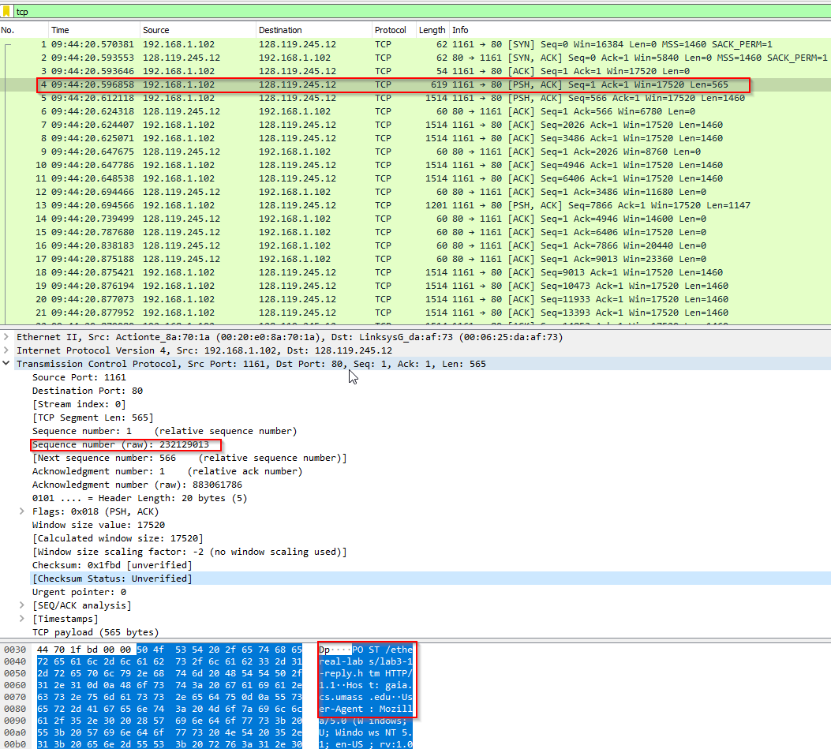

Q7. Consider the TCP segment containing the HTTP POST as the first segment in the TCP connection. What are the sequence numbers of the first six segments in the TCP connection (including the segment containing the HTTP POST)? At what time was each segment sent? When was the ACK for each segment received? Given the difference between when each TCP segment was sent, and when its acknowledgement was received, what is the RTT value for each of the six segments? What is the EstimatedRTT value (see Section 3.5.3, page 239 in text) after the receipt of each ACK? Assume that the value of the EstimatedRTT is equal to the measured RTT for the first segment, and then is computed using the EstimatedRTT equation on page 239 for all subsequent segments.

*Note:* Wireshark has a nice feature that allows you to plot the RTT for each of the TCP segments sent. Select a TCP segment in the “listing of captured packets” window that is being sent from the client to the gaia.cs.umass.edu server. Then select: *Statistics->TCP Stream Graph- >Round Trip Time Graph.*

Answer:

|  |  |  |  |  |  |  |
| --- | --- | --- | --- | --- | --- | --- |
| No | Seq num | Sent time | ACK time | RTT | EstimatedRTT | Data Length |
| 1 | 232129013 | 09:44:20.596858 | 09:44:20.624318 | 0.027460 | 0.027460 | 565 |
| 2 | 232129578 | 09:44:20.612118 | 09:44:20.647675 | 0.035557 | 0.02847213 | 1460 |
| 3 | 232131038 | 09:44:20.624407 | 09:44:20.694446 | 0.070039 | 0.03986725 | 1460 |
| 4 | 232132498 | 09:44:20.625071 | 09:44:20.739499 | 0.114428 | 0.07558763 | 1460 |
| 5 | 232133958 | 09:44:20.647786 | 09:44:20.787680 | 0.139894 | 0.11761125 | 1460 |
| 6 | 232135418 | 09:44:20.648538 | 09:44:20.838183 | 0.189645 | 0.14611288 | 1460 |

*EstimatedRTT=(1−α)*⋅*EstimatedRTT+α*⋅*SampleRTT (α= 0.125)*

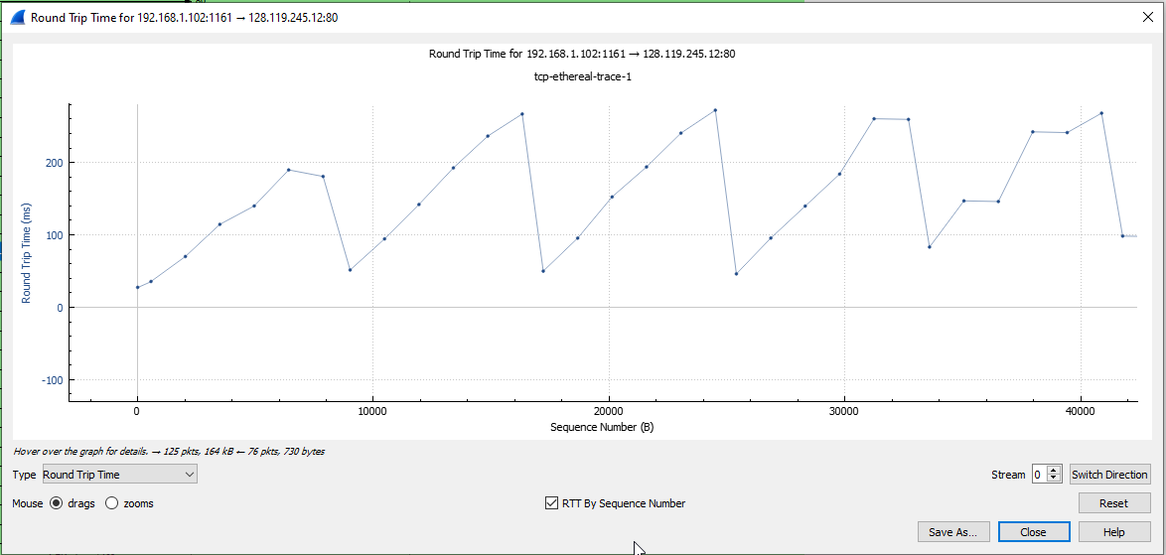

Q8. What is the length of each of the first six TCP segments?

Answer:

|  |  |  |
| --- | --- | --- |
| No | Seq num | Data Length |
| 1 | 232129013 | 565 |
| 2 | 232129578 | 1460 |
| 3 | 232131038 | 1460 |
| 4 | 232132498 | 1460 |
| 5 | 232133958 | 1460 |
| 6 | 232135418 | 1460 |

Q9. What is the minimum amount of available buffer space advertised at the receiver for the entire trace? Does the lack of receiver buffer space ever throttle the sender?

Answer:

Sort the destination in wireshark capture list, the destination to 192.168.1.102 are ACK from server. We can see the minimum amount of window size is 5840. And the client sending data max size is 1460. So there is no lack of receiver buffer space case.

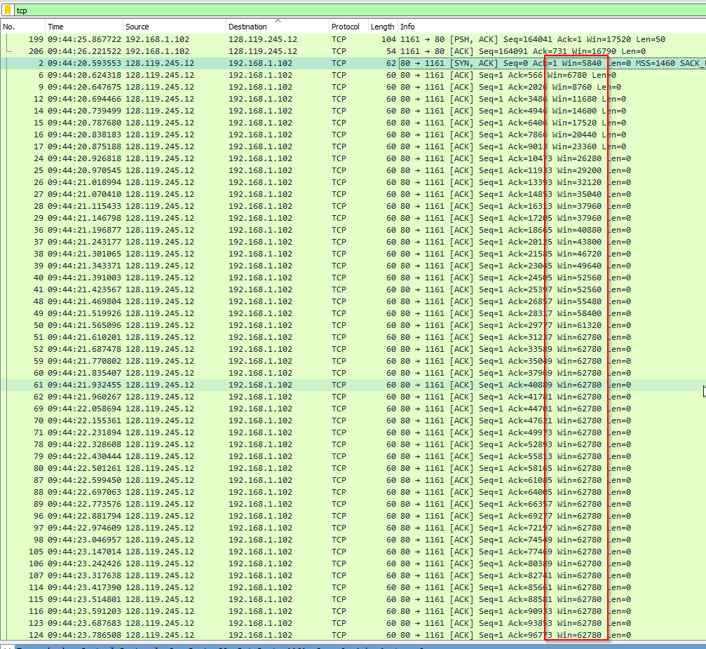

Q10. Are there any retransmitted segments in the trace file? What did you check for (in the trace) in order to answer this question?

Answer:

There is no retransmitted segments in the trace file. After sorted the destination column, we only the segment sent to server, and check the seq number, if any segment is retransmitted, the sequence number should be same as before, but from below figure, I didn’t find any same sequence number case.

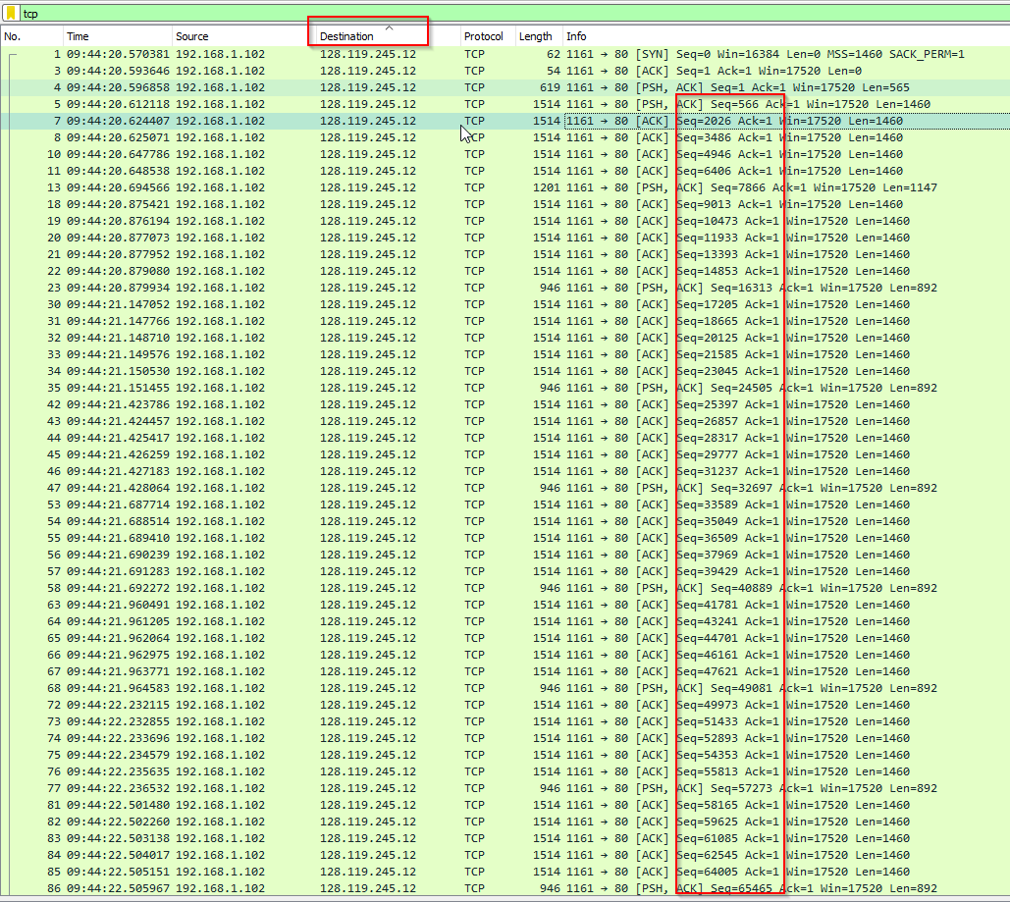

Q11. How much data does the receiver typically acknowledge in an ACK? Can you identify cases where the receiver is ACKing every other received segment (see Table 3.2 on page 247 in the textbook)?

Answer:

1. Typically 2920 bytes data acknowledged if we calculate every ACK number from receiver
2. From below figure, we can see the receiver is ACKing every other received segment.

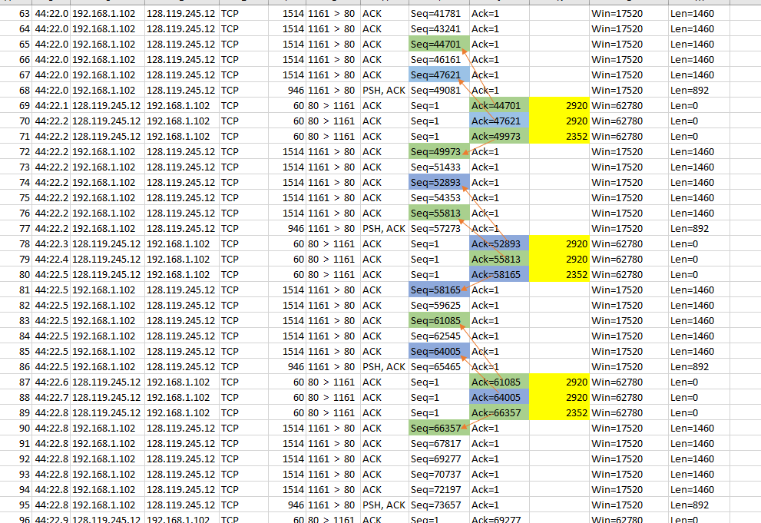

Q12. What is the throughput (bytes transferred per unit time) for the TCP connection?

Answer:

For one block:

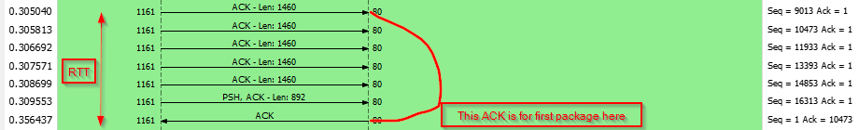

RTT = 0.356437 – 0.305040 = 0.051397 seconds

Total data = (1460 * 5 + 892) * 8 = 65536 bits

Throughput = 65536/0.051397 = 1275094 bit/s

For overall TCP connection:

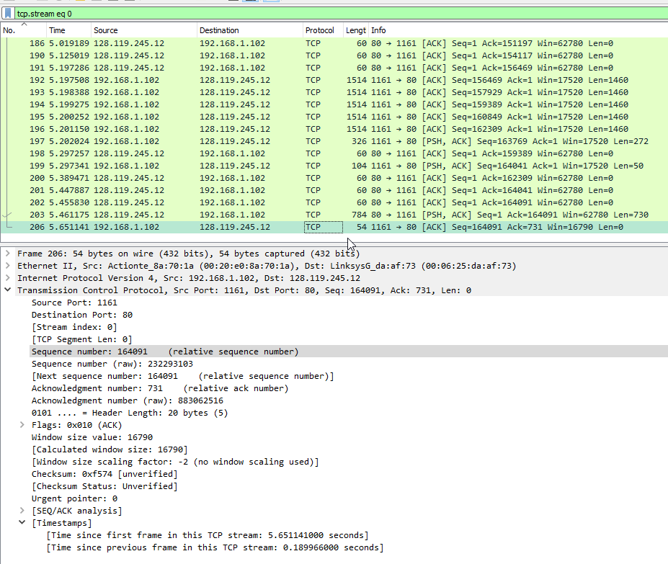

Total time = 5.651141 second

Total bytes = 164091

Throughput = 164091/5.651141 = 29037 bit/s

Q13. Can you identify where TCP’s slow-start phase begins and ends, and where congestion avoidance takes over? Comment on ways in which the measured data differs from the idealized behavior of TCP that we’ve studied in the text.

Answer:

For tcp-ethereal- trace-1:

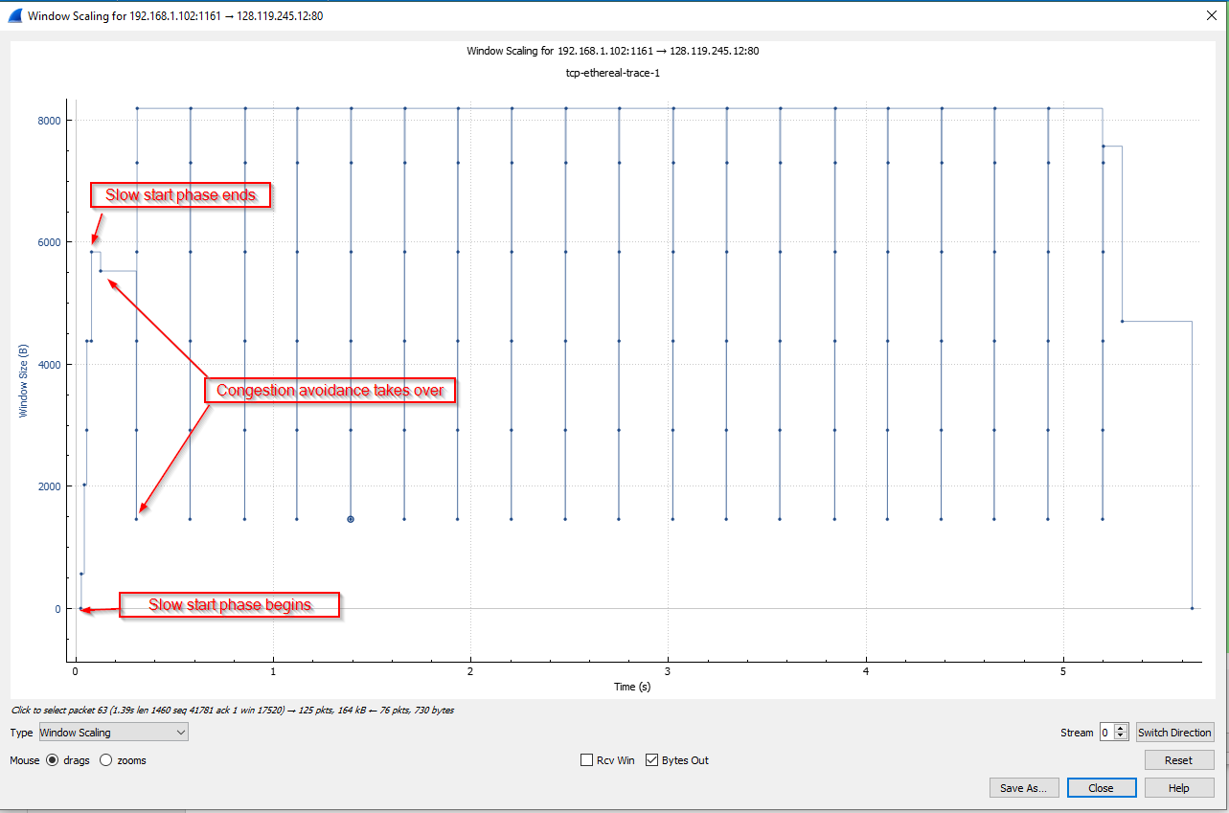

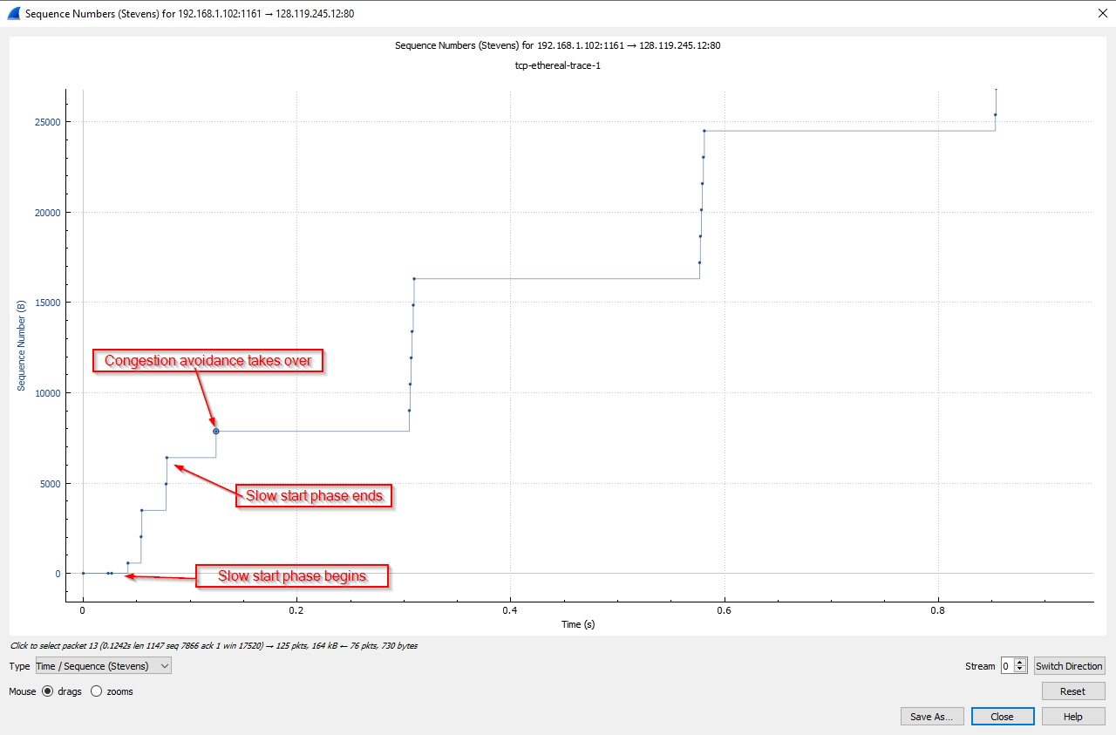

Q14. For the trace that you have gathered when you transferred a file from your computer to gaia.cs.umass.edu, answer each of the last two questions.

